User Manual

Project Measure Sound





**By PLA31**

Dominik

Omer

Sven

Christiaan

Xaland Durrani

Table of Contents

* Introduction 2
* Home 3
* About 4
* Login 5
* Registration 6
* Contact 7
* The Map 8

Introduction

As team 31 we decided to make a map which displays the amount of noise made in a certain area. The noise levels will be displayed using different colors. Red meaning the area has a lot of noise, while green will be a quiet area. This manual is provided for you to easily use the website. In this manual we will explain how you can operate on the website and login to your Planet account for example and many other things.

Home

When you open the website, you will first be directed to the Home page. There will be a welcome text: “Welcome to Project Measure Sound” There will also be a menu section with different page names. The menu section is permanent on the website despite the page you’re on. Finally, there will be a button “Tell me more” underneath the welcome text.

The home page is a central point on the website and a way to welcome you.

Menu section

1. The menu section contains the following page names:

* Home
* About
* Login
* Registreer
* Contact

1. If you want to go to one of these pages you have to click on them with your mouse.
2. The system opens the page you have clicked on.

Button “Tell me more”

1. If you want to go to the “About” page you have to click on this button with your mouse.
2. The System opens the “About” page.

About

When you get directed to the About page, there will be a text in a big orange box. There will also be a menu section. The About page is to inform you about our project.

Menu section

1. The menu section contains the following page names:

* Home
* About
* Login
* Registreer
* Contact

1. If you want to go to one of these pages you have to click on them with your mouse.
2. The system opens the page you have clicked on.

About Text

1. 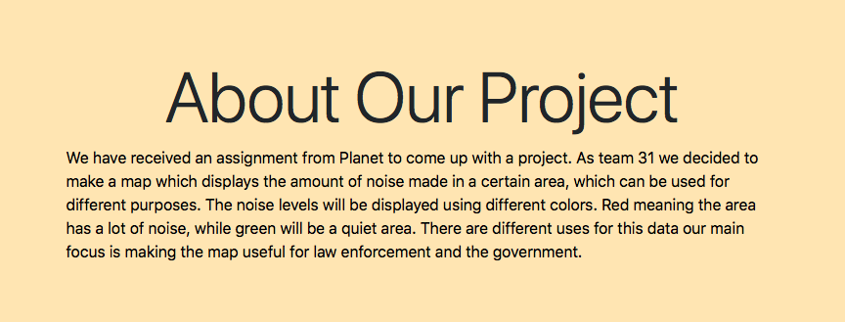

Login

When you get directed to the Login page, there will be two input boxes, checkbox, a button and a “forgot password?” link all in a big grey box. There will also be a menu section. The Login page is to login to your Planet account to get access to the map. You can also reset your password on the Login Page.

Login

1. ENTER your email into the input box “Enter Email…”
2. ENTER your password into the input box “Enter Password…”
3. If you want to remember your credentials for the next time, then click on the checkbox “Remember me”.
4. Click the button “Login” to login to your Planet account.
5. The System will direct you to the map.

Forgot Password

1. Click “Forgot Password ?” to reset your password.
2. The System will take you to the reset password page.
3. The system administration will process your request.

Menu section

1. The menu section contains the following page names:

* Home
* About
* Login
* Registreer
* Contact

1. If you want to go to one of these pages you have to click on them with your mouse.
2. The system opens the page you have clicked on.

Registreer

When you get directed to the Registreer page, there will be two input boxes, and a button all in a big grey box. There will also be a menu section. The Registreer page is to register for a Planet account to get access to the map.

Registreer

1. ENTER your email into the input box “Enter Email…”
2. ENTER your password into the input box “Enter Password…”
3. Click the button “Registreer” to register your Planet account.
4. The System will direct you to the login page.

Menu section

1. The menu section contains the following page names:

* Home
* About
* Login
* Registreer
* Contact

1. If you want to go to one of these pages you have to click on them with your mouse.
2. The system opens the page you have clicked on.

Contact

When you get directed to the Contact page, there will be three input boxes, checkbox and a button all in a big grey box. There will also be a menu section. The Contact page is to get in contact with Planet to ask a question about the website for example.

Contact Form

1. ENTER your name into the input box “Please enter your name…”
2. ENTER your email into the input box “Please enter your email…”
3. ENTER your message into the input box “Please enter your message…”
4. If you are a human, then click on the checkbox “I am human” to confirm this.
5. Click the button “Send message” to send a message to Planet.
6. The System will take you back to the Contact page.

Menu section

1. The menu section contains the following page names:

* Home
* About
* Login
* Registreer
* Contact

1. If you want to go to one of these pages you have to click on them with your mouse.
2. The system opens the page you have clicked on.

The Map

When you get directed to the Map page, there will a blanc pop up message, what you will do after this will be described here.

Map

1. Click the button “OK” to continue.
2. After this the system will show the map.
3. Click on the colored dots by your choice to show data of the sensors.
4. The System will display the name of the sensor, the latest output and below the chart of the previous outputs.
5. By hovering over the chart, you can see the exact number output.
6. You can zoom in and out on the map by clicking on the plus or minus button.
7. To move the map, hold down and drag the map in your preferred direction.

Menu section

1. The menu section contains the following page names:

* Home
* About
* Login
* Registreer
* Contact

1. If you want to go to one of these pages you have to click on them with your mouse.
2. The system opens the page you have clicked on.